Taiichi Ohno
1912-1990
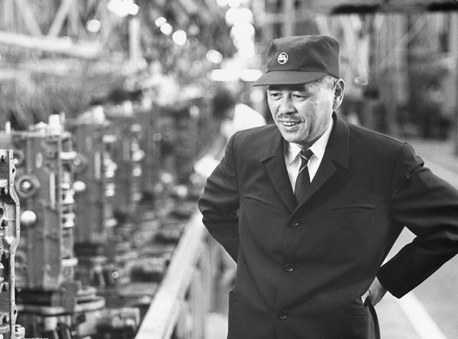
Taiichi Ohno is widely regarded as the originator of the Toyota Production System, often called "lean manufacturing" in the U.S. The overall approach aims to reduce waste, defined as work or time that doesn't add value. In his book, Toyota Production System: Beyond Large-Scale Production, Ohno wrote that "the basis of the Toyota Production System is absolute elimination of waste. The two pillars that this is based on are just-in-time and autonomation. In just-in-time production, a later process goes to an earlier process in the operation flow and withdraws only the number of parts needed, when they are needed. Autonomation refers to automating a process to include inspection. Human attention is necessary only when a defect is detected (the machine will stop and not continue until the problem is solved)."
A second pillar of the Toyota system was the creation of standard work definitions. These described the methods for accomplishing each procedure in each plant. They included cycle times, the work sequence, and standard inventory. The idea was to have a clear definition of "current practice" so that (1) it could be transferred to a new facility and (2) it could be improved and a new, better standard defined. Ohno did not believe that continuous improvement could be achieved without a clear standard defining current practice and outcome.
One of Ohno's best-known shop-floor consultants was Shigeo Shingo (1909-1990). Shingo is credited with developing the single-minute Exchange of Die (SMED) technique. (Actually, SMED means single-digit exchange, but that is a bad acronym.)
In the early 1950s, Toyota's strategic problem was that its volume was very small. The techniques for making automobiles had been developed in Detroit, and they relied on very long production runs. Thus, a stamping machine might stamp out 100,000 right door panels. Then, after a day to change dies, it might stamp out 100,000 left door panels. Shingo knew that Toyota could only compete by dramatically reducing the time to make a die change. If that could be drastically reduced, the impact of volume on costs would be cut. In the late 1940s, die changes at Toyota took 3 hours. By 1955, that time had been reduced to 15 minutes. By 2010, it was 3 minutes.
Shingo said that the steps involved were:
- Distinguish all operations that do not need to stop during the set-up.
- Make all preparations while the process is running. Modify the equipment so this is possible
- Standardize parts in the setup process to eliminate the need for readjustments and to make the setup job more routine.
- Design clamps and fasteners to eliminate bolts or screws. Fasteners should snap into place.
- Put as much as possible on wheeled carts with parts and equipment at the right working heights.
Shingo's contributions were an important part of the Toyota Production System, which emphasized a steady flow of product with minimal inventory. In effect, the system reduced the time it took to move raw materials to a product in the buyer's hands.

